 | 26.10.5 Editors - Properties Editor - Particle Properties Tab - Emitter - Render panel
Table of content
Render Panel 2
Render As 2
All render methods 2
Scale 2
Scale Randomness 2
Show Emitter 2
None 2
Halo + Line 2
Material 3
Coordinates System 3
Extra 3
Parents Particles 3
Unborn 3
Dead 3
Path 3
Material 3
Coordinates System 3
Path subpanel 3
B-Spline 3
Steps 3
Timing subpanel 4
Absolute Path Time 4
End 4
Random 4
Extra 4
Parents Particles 4
Unborn 4
Dead 4
Object 4
Object subpanel 4
Instance Object 4
Global Coordinates 4
Object Rotation 4
Object Scale 4
Extra 5
Parents Particles 5
Unborn 5
Dead 5
Collection 5
Collection subpanel 5
Instance Collection 5
Whole Collection 5
Pick Random 5
Global Coordinates 5
Object Rotation 5
Object Scale 5
Use Count 6
Dupli Object Index list 6
Drag Handler 6
Search Field 6
Invert 6
Sort by Name 6
Copy particle Dupliobject 6
Remove particle Dupliobject 6
Refresh Dupliobjects 6
Count 6
Extra 6
Parents Particles 6
Unborn 6
Dead 6

Render Panel

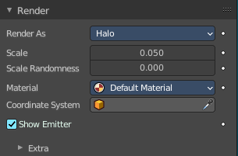
The Render Panel controls how particles appear when they are rendered.
Note! Cycles supports only Object and Collection render types. Halo Line and Path are not supported.

Render As
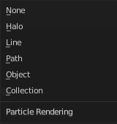
Render the particles with different methods.

All render methods

Scale
The size of the particles.

Scale Randomness
Give the particles a random size.

Show Emitter
Render the particle emitting mesh. This does not affect the viewport rendering!

None

Don't render the particles.

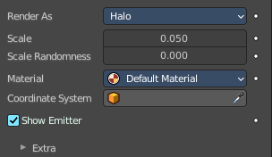
Halo + Line
Line renders the particles as lines. Halo are rendered as glowing dots or a little cloud of light. Although they are not really lights because they do not cast light into the scene like a light object. They are called Halos because you can see them, but they do not have any substance.

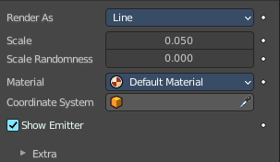
Material
Set which of the object’s materials is used to shade the particles.

Coordinates System
Use a different object’s coordinates to determine the birth of particles.

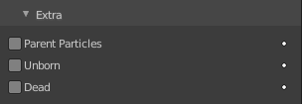
Extra

Parents Particles
Render also parent particles if child particles are used. Children have a lot of different deformation options, so the straight parents would stand between their curly children. So by default Parents are not rendered if you activate Children. See Children.

Unborn
Render particles before they are born.

Dead
Render particles after they have died. This is very useful if particles die in a collision Die on hit, so you can cover objects with particles.

Path
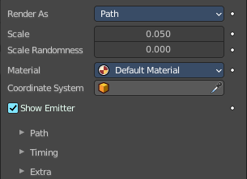
The Path visualization needs a Hair particle system or Keyed particles.

Material
Set which of the object’s materials is used to shade the particles.

Coordinates System
Use a different object’s coordinates to determine the birth of particles.

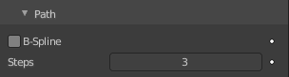
Path subpanel

B-Spline
Interpolate hair using B-splines. This may be an option for you if you want to use low Render values. You loose a bit of control but gain smoother paths.

Steps
Set the number of subdivisions of the rendered paths (the value is a power of 2). You should set this value carefully, because if you increase the render value by two you need four times more memory to render. Also the rendering is faster if you use low render values (sometimes drastically). But how low you can go with this value depends on the waviness of the hair (the value is a power of 2). This means 0 steps give 1 subdivision, 1 give 2 subdivisions, 2 –> 4, 3 –> 8, 4 –> 16, … n –> n2.

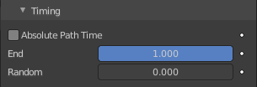
Timing subpanel

Absolute Path Time
Path timing is in absolute frames.

End
End time of the practical path.

Random
Give the path length a random variation.

Extra

Parents Particles
Render also parent particles if child particles are used. Children have a lot of different deformation options, so the straight parents would stand between their curly children. So by default Parents are not rendered if you activate Children. See Children.

Unborn
Render particles before they are born.

Dead
Render particles after they have died. This is very useful if particles die in a collision Die on hit, so you can cover objects with particles.

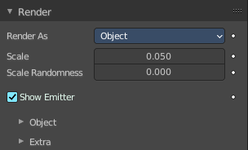
Object

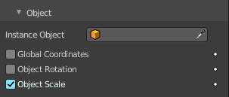
Object subpanel

Instance Object
The specified object is instanced in place of each particle.

Global Coordinates
Use object’s global coordinates for instancing.

Object Rotation
Use the rotation of the object.

Object Scale
Use the size of the object.

Extra

Parents Particles
Render also parent particles if child particles are used. Children have a lot of different deformation options, so the straight parents would stand between their curly children. So by default Parents are not rendered if you activate Children. See Children.

Unborn
Render particles before they are born.

Dead
Render particles after they have died. This is very useful if particles die in a collision Die on hit, so you can cover objects with particles.

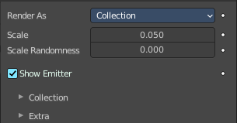
Collection

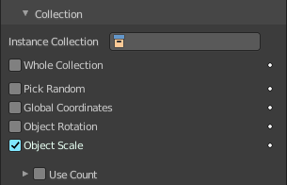
Collection subpanel

Instance Collection
The objects that belong to a collection are instanced sequentially in the place of the particles.

Whole Collection
Use the whole group at once, instead of one of its elements, the group being displayed in place of each particle.

Pick Random
The objects in the group are selected in a random order, and only one object is displayed in place of a particle. Please note that this mechanism fully replaces old Blender particles system using parentage and Instancing Verts to replace particles with actual geometry. This method is fully deprecated and does not work anymore.

Global Coordinates
Use object’s global coordinates for instancing.

Object Rotation
Use the rotation of the objects.

Object Scale
Use the size of the objects.

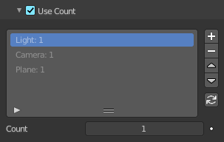
Use Count
Use objects multiple times in the same groups. Specify the order and number of times to repeat each object with the list view that appears.

Dupli Object Index list
The list with the objects of the chosen instance collection.

Drag Handler
The two vertical lines at the end is a handler with which you can expand the list.

Search Field

You can expand a search field at the bottom of the list. Type in your term and hit enter to filter for your term.

Invert
Exclude the search term instead of searching for it.

Sort by Name
Sort the List by name.

Copy particle Dupliobject
Duplicate an object in the list.

Remove particle Dupliobject
Remove a duplicate from the list.

Refresh Dupliobjects
Refreshes the Dupli Object Index list.

Count
The number of times this object is repeated with respect to other objects.

Extra

Parents Particles
Render also parent particles if child particles are used. Children have a lot of different deformation options, so the straight parents would stand between their curly children. So by default Parents are not rendered if you activate Children. See Children.

Unborn
Render particles before they are born.

Dead
Render particles after they have died. This is very useful if particles die in a collision Die on hit, so you can cover objects with particles.

